Placement Statistics

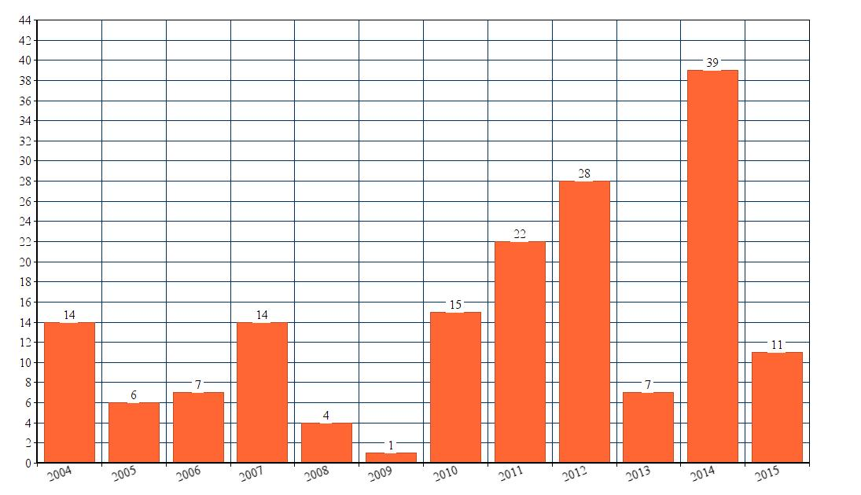
Year Wise Total Placements:
Sl. no | Year | No of Students Selected
1 | 2004 | 14
2 | 2005 | 6
3 | 2006 | 7
4 | 2007 | 14
5 | 2008 | 4
6 | 2009 | 1
7 | 2010 | 15
8 | 2011 | 22
9 | 2012 | 28
10 | 2013 | 7
11 | 2014 | 39
12 | 2015 | 11

- Company Wise Total Placements:
Sl.No | Company | Year | No of Students Selected
1 | ZITT Technologies Ltd, Hyderabad | 2004 | 14
2 | TATA Consultancy Services | 2005 | 4
3 | Hindustan Aeronautical Ltd. Bangalore | 2005 | 1
4 | Microsoft Corporation | 2005 | 1
5 | Wipro Technologies | 2006 | 1
6 | Value Labs | 2006 | 1
7 | GE Software | 2006 | 4
8 | Satyam Computer | 2006 | 1
9 | Infosys | 2007 | 1
10 | Wipro Technologies | 2007 | 1
11 | Satyam Computer | 2007 | 3
12 | 24X7 Company | 2007 | 3
13 | Brigade Corporation | 2007 | 1
14 | App Labs | 2007 | 1
15 | Value Labs | 2007 | 2
16 | Nokia | 2007 | 1
17 | Lifetime soft | 2007 | 1
18 | Mphais | 2008 | 1
19 | ICICI Securities | 2008 | 3
20 | Six Sigma Limited | 2009 | 1
21 | Infosys | 2010 | 3
22 | Mahindra Satyam | 2010 | 1
23 | CSC | 2010 | 3
24 | Coromandel International Ltd. | 2010 | 1
25 | SAN Capital | 2010 | 4
26 | IBM | 2010 | 1
27 | Oakridge International School, Hyd | 2010 | 2
28 | Mahindra Satyam | 2011 | 8
29 | SYNTEL | 2011 | 2
30 | FACTSET | 2011 | 1
31 | APPS ASSOCIATES | 2011 | 2
32 | MPHASIS | 2011 | 2
33 | GENPACT | 2011 | 1
34 | CUMMINS | 2011 | 4
35 | Infosys | 2011 | 1
36 | MPHASIS | 2011 | 1
37 | INFOSYS | 2012 | 3
38 | CGI | 2012 | 2
39 | HCL | 2012 | 1
40 | ANU SOLAR | 2012 | 3
41 | SEJAL | 2012 | 8
42 | TECH GENIUS | 2012 | 1
43 | INDIA INFOLINE | 2012 | 3
44 | TATA MOTORS | 2012 | 1
45 | LIFE CELL | 2012 | 3
46 | ASHAYAM TECHNOLOGIES | 2012 | 1
47 | EXPONENT | 2012 | 1
48 | UAEXCHANGE | 2012 | 1
49 | The Career Council | 2013 | 3
50 | Techgenius Solutions | 2013 | 1
51 | Gaur Engineering Company | 2013 | 1
52 | Asha Bhanu Group | 2013 | 2
53 | IMS Recruitment company | 2014 | 5
54 | HCL,Corp, Slocum YEP | 2014 | 2
55 | Novell Solutions India Pvt.Ltd | 2014 | 1
56 | WIPRO Tech Support | 2014 | 1
57 | OASIS Recruitment Consultancy | 2014 | 1
58 | Emphasis IT Solutions, Bangalore | 2014 | 1
59 | LIC LIFE PLUS | 2014 | 23
60 | MYHALOM | 2014 | 5
61 | DELL | 2015 | 11

Thank You
Do Visit Us

